|  |  |  |
| --- | --- | --- |
| **Model** | **Mean Absolute Error (averaged over 10 folds)** | **Standard Deviation** |
| Basic Mean Model | 12.758 | 0.089 |
| Linear Regression | 11.301 | 0.029 |
| Neural Network | 11.066 | 0.69 |
| Random Forests |  |  |
| Gradient Boosting |  |  |
| Ensemble Stack |  |  |

Performance on all our different models

Neural Network – Performance with respect to the number of hidden neurons

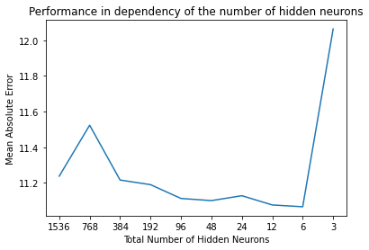

Computation time for the different amount of hidden neurons

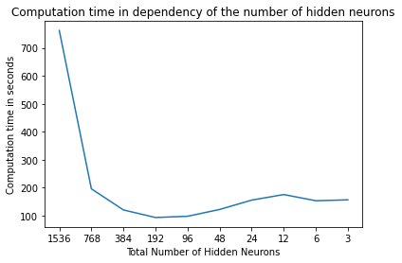

Here we can clearly see (96 hidden neurons) that as the training data are learned the training error decreases but the validation error stays pretty much the same throughout. An efficient learning seems impossible.

